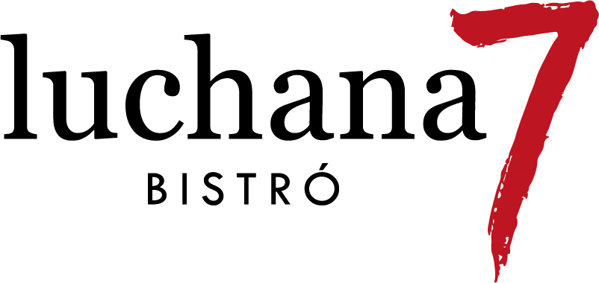
BRUNCH Available from 9:00 a 24:00 h
Toast (whole grain or white) with jam, tomato, honey or peanut butter – 2.50 €
Butter croissant – 2.20 € (grilled 2.50 €)
Butter croissant with almond, pistachio or lotus filling – 3.90 €
Cinnamon roll / Pecan roll – 4 €
Oven-baked butter croissant with ham, cheese, rocket & cherry tomatoes – 4.90 €
Butter croissant with eggs, bacon, cheese & baby greens – 5.90 €
Caprese butter croissant with basil, tomatoes & mozzarella – 5.90 €
Eggs Benedict with salmon, bacon or comté cheese – 11.90 €
Eggs your way with toast – 7 €
Croque Monsieur gratinated with béchamel and smoked ham – 9 €
French Toast with mascarpone & berry compote – 8 €
Thick pancakes with mascarpone & fruit of choice – 8 €
Big Yogurt Bowl with fruits, granola, seeds, peanut butter and honey – 7.90 €
Açai Bowl – 9.50 €
hazelnut cream +1€, peanut butter +1€, milk powder +1€

Extras: egg 1.70 €, guacamole 1.80 €, bacon 2.50 €, bread 1.50 €, halloumi 3.50 €, salmon 3 €, comté 2 €, fries 2 €

We are refining our menu – We would love your feedback

ENGLISH
TOASTS & SANDWICHES
Available from 9:00 a 24:00 h
Tumaca toast with Iberico ham – 7.90 €
Braised chicken toast with avocado & chipotle – 8.50 €
Guacamole & burrata toast with salmon – 9.80 €
Smoked salmon toast with avocado & watercress – 9.80 €
Avocado, feta & jalapeño toast – 9.80 €
Bikini Brioche (ham & cheddar) – 7.50 €
LE COQ Sandwich chicken, halloumi, avocado, lettuce, almonds and lemon mayo – 10.50 €
Reuben Sandwich pastrami on crunchy bread with Gruyère cheese and sauerkraut– 11 €
Burger with bacon, manchego cheese & fries – 12 €
(+guacamole 1 € / +sweet potato fries 1 €)

CREAMY SPANISH OMELETTES made to order
Available from 13:00 a 24:00 h
Traditional “Tortilla de patatas” – 12.50 €
Truffled / Chistorra & brie – 12.90 €
Gorgonzola – 14 €
Iberico ham vaga omelette – 14 €
Tuna vaga omelette – 14 €

TAPAS & MORE Available from 13:00 a 24:00 h
BravaLuchanas our-style patatas bravas — choose classic or sweet potato – 6.90 €
Ham croquettes (6 pcs) – 7.50 €
Panko prawns with Thai mango sauce – 10.90 €
Iberico ham platter – 19.90 €
Russian salad our classic version of Spanish potato salad with tuna, vegetables and mayo – 9.75 €

INTERNATIONAL DISHES
Tuna Tataki – 13 €
Chicken Supreme with pesto & mozzarella – 12.90 €
Slow-cooked Secreto pork – 19 €
HEALTHY CORNER
Pink “Ensaladilla” a lighter, beetroot-based version – 9 €
Barbastro tomato salad with tuna belly – 12 €
Burrata salad with tomato granita – 14 €
Soup of the day – 5.90 €

Soup of the day* 5,9€

SWEET STOP
check the display counter
Warm cookie with ice cream – 6 €
Caramelized Torrija – 6 €
Cheesecake – 5.30 €
Key Lime Pie – 5.30 €
Carrot Cake – 5.30 €
Tres Leches – 5.30 €
Banoffee – 5.30 €
Brownie – 4.90 €

Opening offer 19.9€
Spanish omelette of your choice plus a bottle of Verdejo white wine

Weekday Lunch Menu* 12.9€
(Monday to Friday, 13:00–16:00, non-holidays)
Dish of your choice with a drink* included
+ soup of the day €3 · + coffee €1*

We are refining our menu – We would love your feedback

COFFEE
Café de Finca – El Retiro (Guatemala)
Intense aromatic profile where brown sugar and cocoa stand out.
Medium body and soft acidity with notes of orange and red apple.

Espresso 2.20 € · Double 2.90 €
Cortado 2.30 €
Latte — L 2.70 € · XL 3.60 €
Flat White 3.50 €
Cappuccino 3.20 €
Café Bombón 3.50 €
Americano 2.70 €
Carajillo 3.90 €
Mocha 3.50 €
Affogato 3.70 €
+0.20 € plant-based milk alternative
+0.20 € extra shot of coffee

ICED & SPECIAL COFFEES
Iced Vanilla Latte — L 4.50 € · XL 5.50 €
Iced Orange Coffee — L 4.50 € · XL 5.50 €
Iced Tonic Coffee — L 4.50 € · XL 5.50 €

TEAS & INFUSIONS
Teas and Infusions 3, €
Iced Matcha Latte w/ oat milk L 4,5€ XL 5,5€
Iced Chai Latte L 4,5€ XL 5,5€
Fruit Iced Tea 4,9 €
HOT DRINKS
Golden Milk Latte (turmeric, ginger milk, lime & honey) L 3,8 XL 4,6 €
Matcha Latte L 3,8€ XL 4,6€
Chai Latte L 3,80€ XL 4,6€
Ginger, lime & honey L 3,5€ XL 5€
Hot Chocolate L 3,9€ XL 5€

JUICES & SMOOTHIES
Freshly Squeezed Orange Juice — 4 € (regular) · 6 € (XL)
Mango & Passion Fruit Juice — 5.50 €
Orange, carrot & ginger Juice — 5.50 €
Green Monstera spinach, lemon & apple Juice — 5.50 €
Red Berries Juice — 5.50 €
Vegan Smoothie (oat milk & banana) — 6.50 €
High-Protein Berry Smoothie — 6.50 €

DRINKS
Soft Drinks — 2.90 €

Kombucha — 4.90 €

Mineral Water (still or sparkling, 33 cl) — 2.75 €

Estrella de Galicia (double) — 3.50 €

1906 Estrella de Galicia (double) — 3.30 €

Vermouth with orange slice — 4.20 €

Mimosa — 6 € jug 22 €

Wines / Cocktails & more — see drinks menú

